## ****Order Management Functionality - App Lazada****

****History of Amendments:****

|  |  |  |  |  |
| --- | --- | --- | --- | --- |
| ****Date**** | ****Version**** | ****Modified****  ****Section**** | ****Summary of Change**** | ****Author**** |
| **16/10/2024** | **0.1** |  |  | **Nguyễn Phúc Thịnh** |
|  |  |  |  |  |

**1. Introduction**  
The Lazada app allows users to shop online with a wide variety of products. One of its core features is Order Management, which helps users track, update, and manage their orders from the time of purchase until successful delivery.

**2. Objectives**  
The order management function allows users to:

* Create orders while shopping online.
* View a list of placed orders.
* Track order status (Pending, Shipping, Delivered, Cancelled).
* Cancel orders when necessary (under allowable conditions).
* View order details, including products, prices, payment methods, and shipping addresses.
* Confirm receipt of goods and leave product reviews.

**3. Scope**  
The order management function includes features for both end-users (customers) and administrators, enabling efficient management and tracking of orders.

**4. Definitions, Abbreviations, and Symbols**

* **Order**: The order placed by the customer.
* **Payment**: The process of paying for an order.
* **Shipping**: The process of delivering the order to the customer.
* **Order Status**: The current status of an order (Processing, Shipped, Completed, Cancelled).
* **Delivery**: The process of delivering the order to the customer's address.

**5. Relationship Diagram:**

**5.1. Use case diagram**

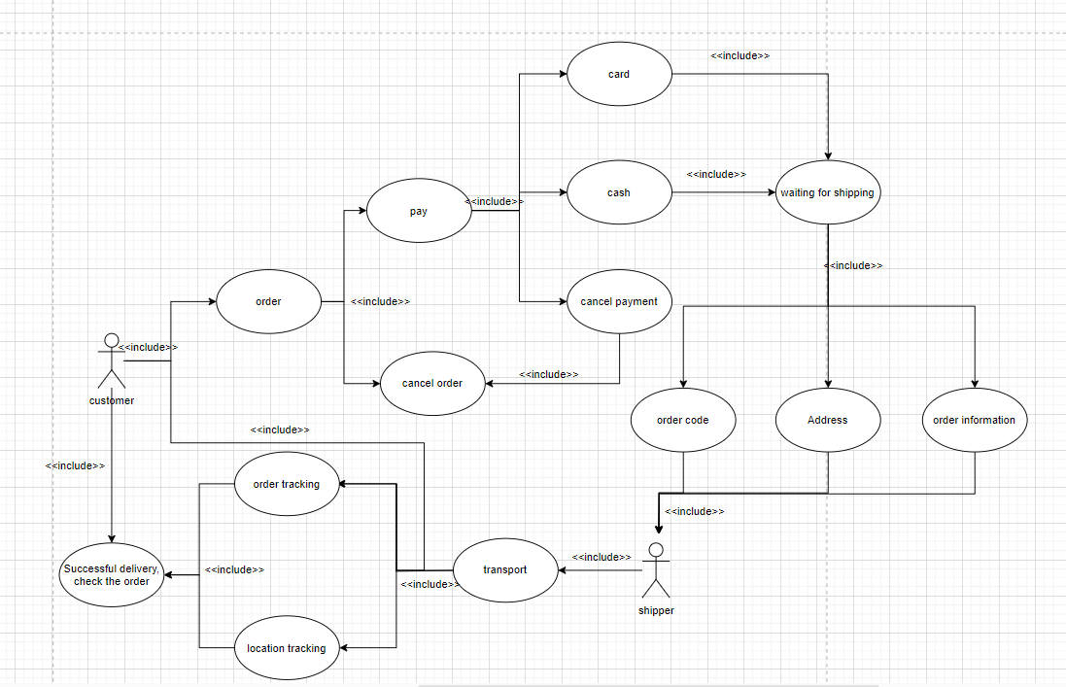

**5.2.Entity relationship diagram**

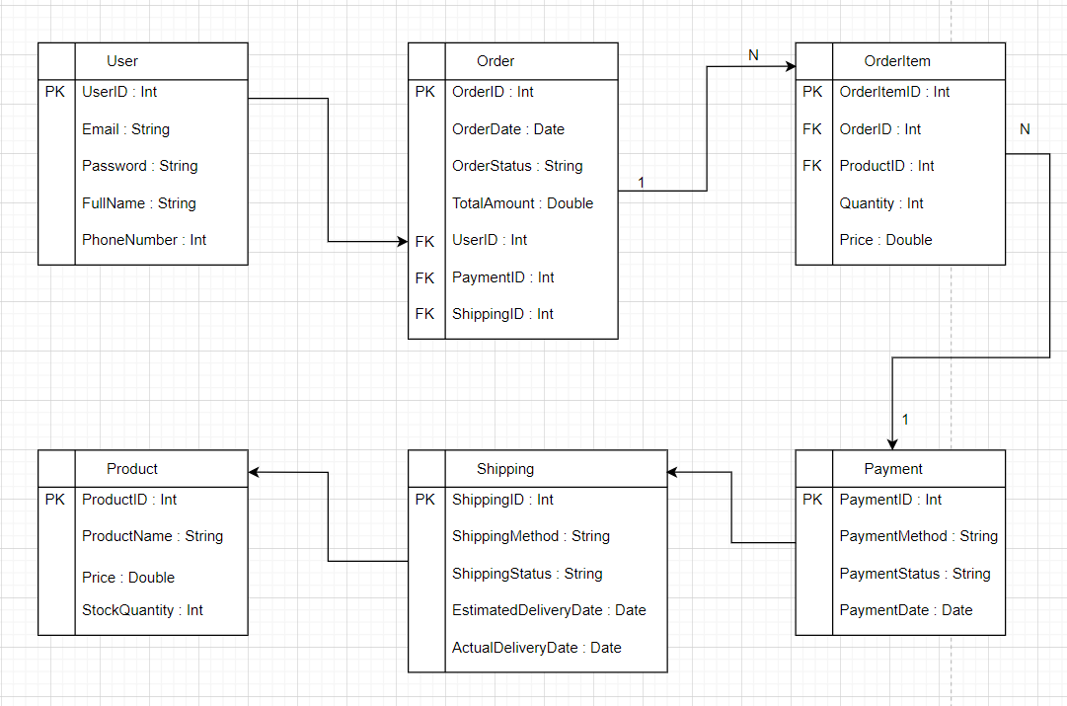

1. **Overview**

|  |  |  |
| --- | --- | --- |
| | **UC Name** | | --- | | Description |
| **UC001**: Create Order | Customer places orders from products in the shopping cart. |
| **UC002**: View Order Details | Customer can view detailed information of each order. |
| **UC003**: Update Order Status | Administrator can update the status of an order. |
| **UC004**: Cancel Order | Customer can request order cancellation before the order is shipped. |
| **UC005**: Track Shipping | Customer can track the shipping process of an order |
| **UC006**: View Order History | Customer can view the history of all orders placed. |

**7. Functional Requirements**

#### ****7.1.**** View Order List

**User**: Customer

**Description**: Customers can view a list of placed orders, including their statuses: Pending, Shipping, Delivered, or Cancelled.

**Input Data**: None.

**Processing**: The system retrieves the list of orders associated with the user’s account.

**Result**: Displays the order list.

****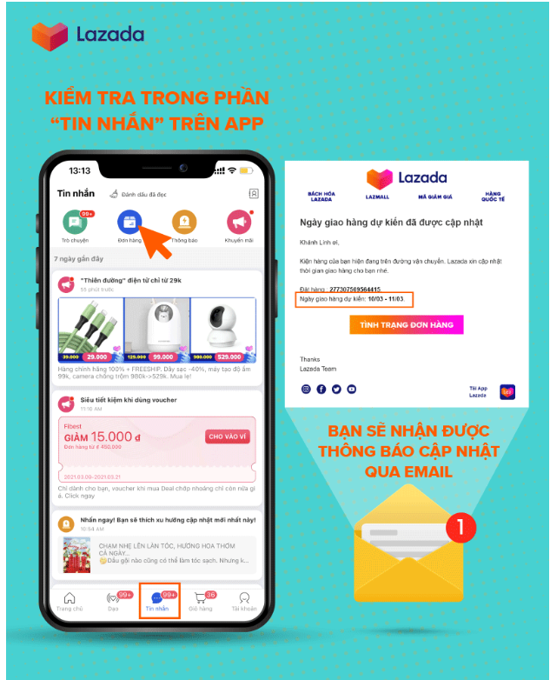****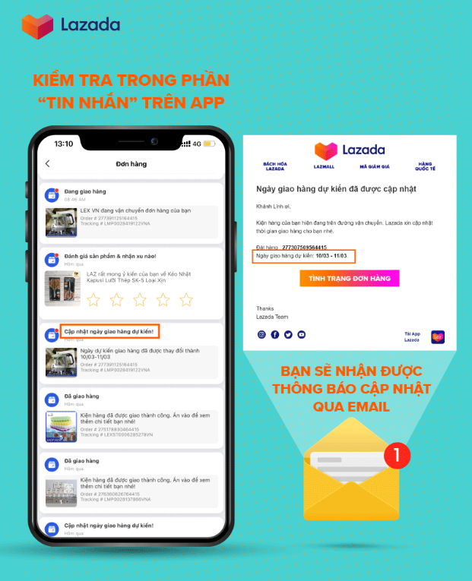

#### ****7.2.**** Cancel Order

**User**: Customer

**Description**: Customers can cancel an order if it hasn’t been shipped yet.

**Input Data**: Order ID.

**Processing**: The system checks the order status. If the order hasn’t been shipped, it will be cancelled and updated in the system.

**Result**: The order is successfully cancelled, and its status changes to "Cancelled."

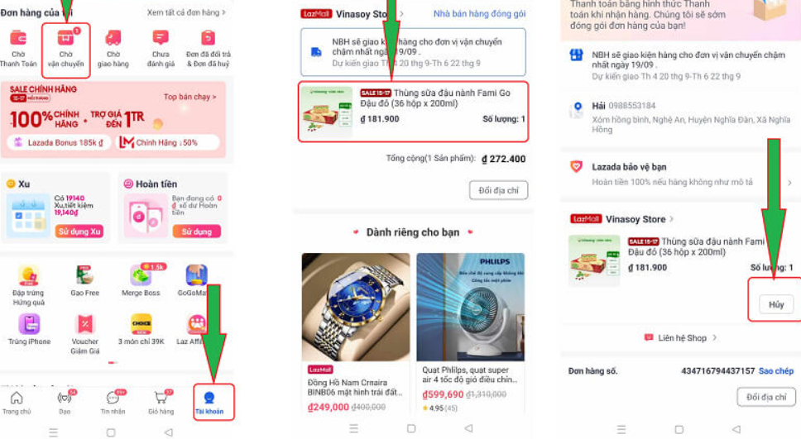

#### ****7.3.**** Track Order Status

**User**: Customer

**Description**: Customers can track the shipping status of their orders.

**Input Data**: Order ID.

**Processing**: The system connects to the shipping carrier and retrieves the current shipping status.

**Result**: Displays the order status, such as "Pending", "Shipping", or "Delivered."



#### ****7.4.**** Confirm Receipt of Order

**User**: Customer

**Description**: After receiving the product, customers can confirm that the order has been successfully delivered.

**Input Data**: Order ID.

**Processing**: The system updates the order status to "Delivered."

**Result**: The order is marked as successfully delivered.

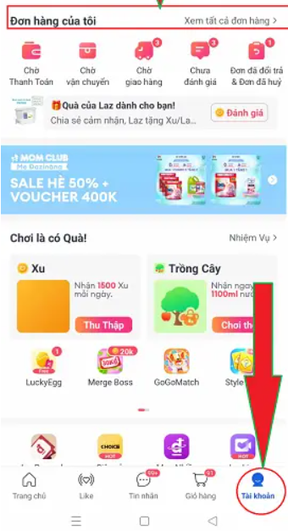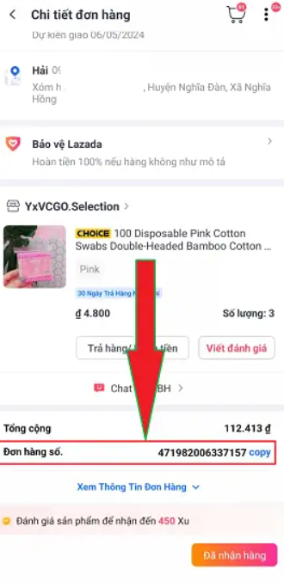

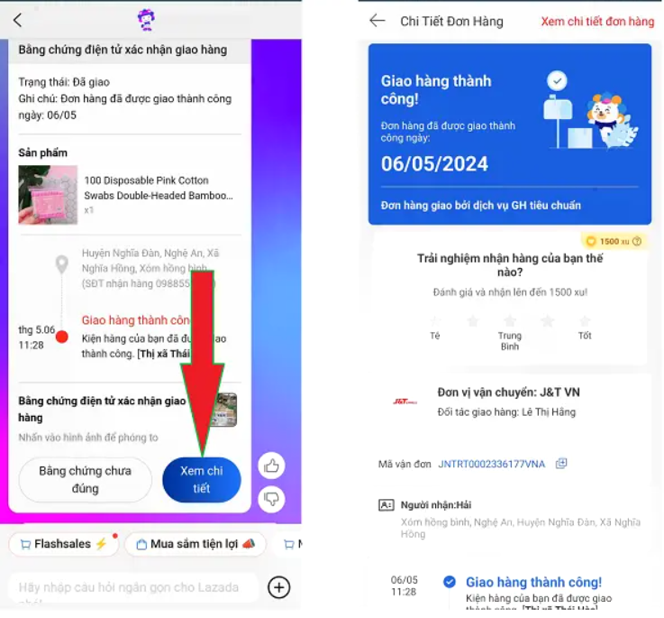

#### ****7.5.**** Product Review

**User**: Customer

**Description**: After receiving the product, customers can leave a review.

**Input Data**: Order ID, review content, and star rating.

**Processing**: The system saves the review and displays it on the corresponding product page.

**Result**: The customer’s review is stored and displayed

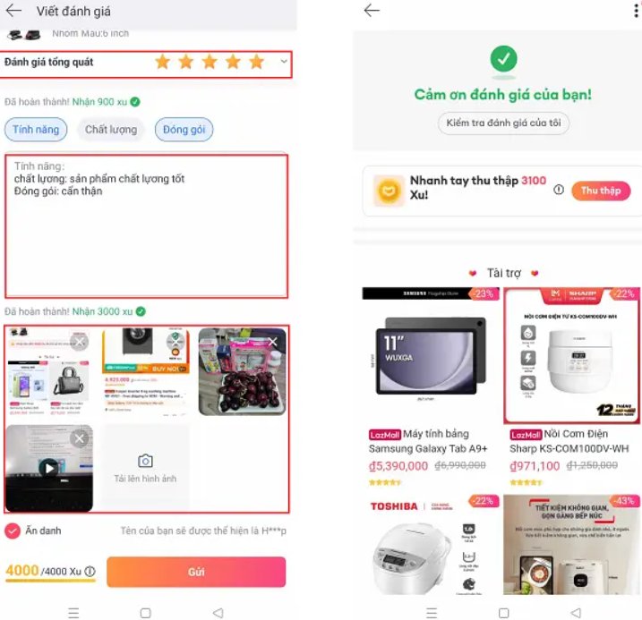

### 8. Non-Functional Features

· **Performance**: The system must respond quickly to order management operations.

· **Security**: Order data must be encrypted, and personal information must be protected.

· **Scalability**: The system must handle a large number of orders simultaneously.

· **Compatibility**: Supports multiple device platforms such as mobile apps and websites.

**9. Conclusion**

This functionality helps users easily track and manage their orders from the time they place them until they receive their items.